CPU SCHEDULING PROCESS

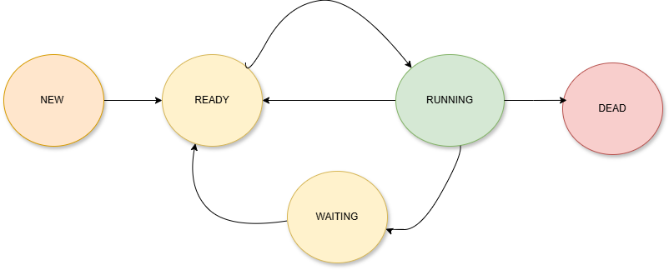

CPU SCHEDULING PROCESS